BOARD OF TRUSTESS KEY MESSAGES

Following are the Key Messages from the Board of Trustees Regular Meeting held on Monday, February 14, 2022.

- Crowsnest Pass Facility Proposal – The Board of Trustees approved the First Reading of the Crowsnest Pass Facility Proposal as presented.
  - Facility proposed is to support the FACES Program for the summer of 2022 / Pursuits Program Sep 2022
    - 2022 FACES program will include a week-long on-site experience for students
    - Site will need to be able to house two sessions at the same time.
    - Current infrastructure cannot house more than one session at a time
    - Funding for the facility is currently available through the sale of other division own property, and programming areas that will utilize the facility (International, FNMI, Summer School).
    - Architects have been engaged to help design the cost-effective facility
    - Tender procurement process will be utilized to enter into a construction management arrangement with the successful contractor.
    - Timeline is to have completed prior to the first of July

- Presentations:

      - FACES PRESENTATION: Mr. Joel Gamache, FACES Principal and Mr. Rick Bullock, FACES Founder and Director presented a FACES (Facilitating Awareness and Character building Experiences for Students) presentation to the Board of Trustees. FACES creates a community that is safe and supportive. This environment fosters connection that deeply impacts students. We have come to understand, that through connection, we more fully understand and feel our personal value. The incredibly inspiring classroom of the “great outdoors” and the powerful metaphors created by adventure activities such as climbing, rappelling, hiking, and canoeing provides an amazing process that results in learning that makes sense, applies to student lives and is engaging and fun. The revised FACES program offers 3 years of learning. To attend you need to complete the Intention to Attend Form online at https://faceseducation.com/registration-info by late February for all second-year students and by early March for all first year students. Specific dates and times to be announced on social media and on the FACES webpage.

Year One:
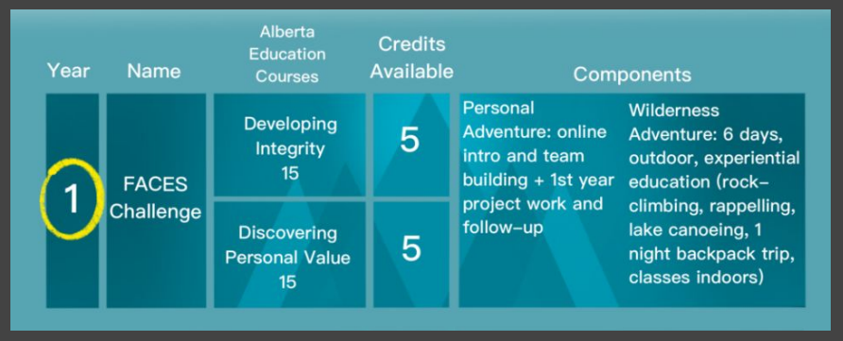
Year Two:
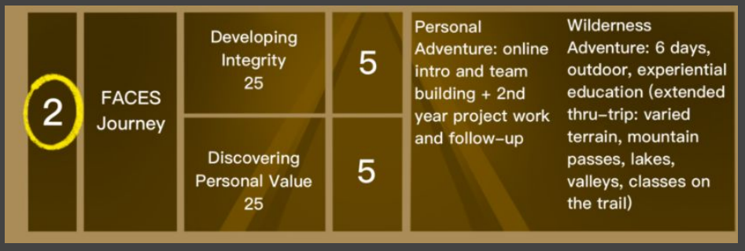

Year Three:
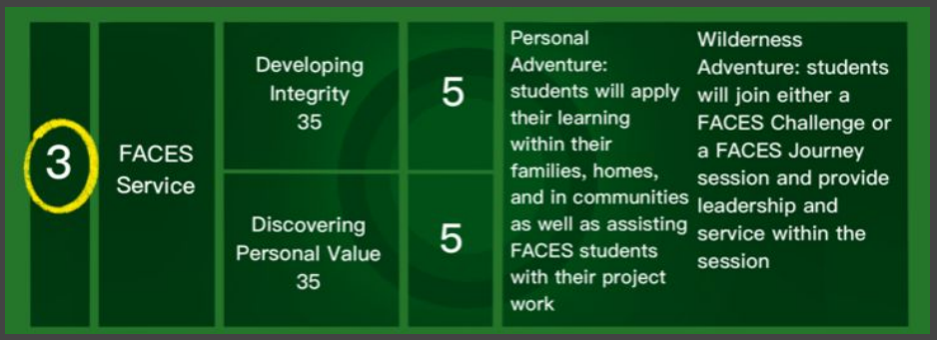

      - Pursuits Presentation – Tara Tanner, Division Principal presented to the Board of Trustees regarding LRSD Pursuits Modelling “Every Student Every Day”.
        - The Virtual School - The virtual school is run by Tara Tanner, Division Principal for Grade 8 -12 and Nick Beer, Granum Principal for Grade 1-7. Currently LRSD has 131 full time students and 225 part time students enrolled in the grade 8-12 virtual school program. Our teachers are able to fulfill the “outreach” role for our schools that do not have a physical outreach building. As a result of this model teachers are able to provide timely, in person support to students needing assistance with virtual school courses. Students can be closely monitored and parents contacted quickly.
        - Home Education: Currently LRSD has 70 students as part of the Home Education program. We offer three, home education PE/Art programs in Fort Macleod, Pincher Creek and Claresholm. We have subscriptions to programs such as Raz Kids, iXL and Mathletics and the program integrates school programming when possible such as One book 5 schools, option classes and sports teams.
        - Summer School 2022: In July 2021, LRSD offered our first summer school program, 65 students participated. The following courses will be offered in the summer school 2022: ELA, SS 10, 20, 30, CALM, HCS 3000, Math 10, 20, Science 10, 14, 24, PE 10, Work Experience/RAP, Media Studies, Tourism, World Religion, Special projects, etc.
        - Pre-Employment/Place Based Programming: LRSD has offered many programs including WHMIS, First Aid, Ski Instructor Level 1 Training, Snowshoeing for classes and Avalanche Safety Training 1. Upcoming programs are CSTS, Safe Food Handling and Plant ID course. These courses are available to all LRSD high school students.

- 2022-2023 Projected Enrolment Numbers – Jeff Perry, Associate Superintendent, Business Services reviewed the projected enrolment numbers, the process for gathering the projections and any relevant trends for the 2022-2023 School Year. The projected enrolment number for FTE students including Home Education, Virtual School and/international Students is 3634. A projected enrolment growth of 81 students from the 2021-2022 School year.

- 2022-23 School Calendar – That the Board of Trustees approved the changes to the draft 2022-2023 School Year calendar as presented. The calendar can be viewed on our website at https://www.lrsd.ca/our-division/calendar/2020-2021-division-school-calendar22

